15 Little River Close
Wooli NSW 2462
7 December, 2011
Clarence Valley Council

Dear Sir/Madam,
Draft Wooli Beach Emergency Action Subplan
I have read the draft EAS and I believe it could be improved by incorporating lessons learned from the 2009 storm. That storm caused erosion of the dune and damage to Council assets (e.g. the beach access near the Reservoir). This access comprises three rows of large sand bags. The Northernmost row was undermined by water, causing it to partially topple northwards away from the other two rows. There was also substantial erosion to the immediate North and South of these sand bags, with significant but less erosion of the dune further North and South.
The cause of erosion in the vicinity of the above access structure was water flowing North to South along the base of the dune at high tide. I did not expect this and I was surprised when I witnessed it. It required a slope on the beach berm from a high ridge about 30 metres east of the dune down to the base of the dune.
The attached photos (taken 40 minutes after a high tide of 1.9m on 6/11/2010) show the beach in a similar condition to that in the storm of 2009.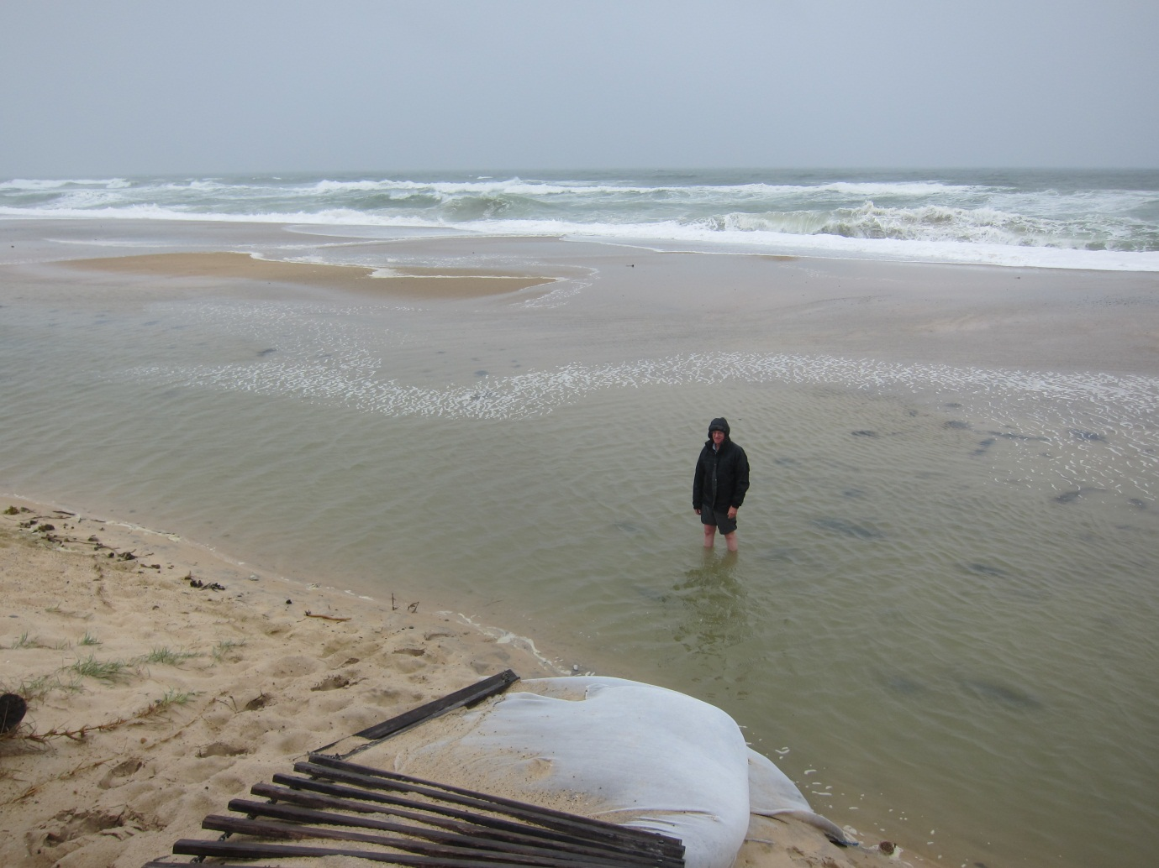 There is a clear ridge in the beach berm (located near the ocean) with water ponding along the base of the dune, which is lower than the ridge. This pond is formed by the larger waves washing over the berm ridge and ponding at the base of the dune. 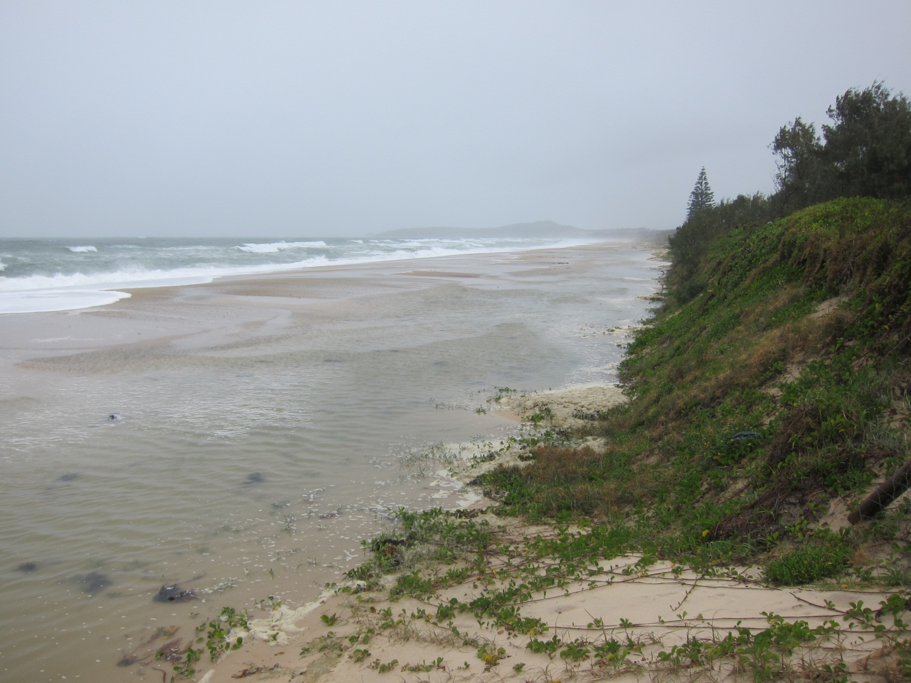
There was a difference in the beach berm in the 2009 and 2010 storms. In 2009, there was a breach in the berm ridge about 100 metres south of the access structure near the reservoir. Each large wave would overtop the berm ridge (for some hundreds of metres) depositing a large volume of water in the pond. As the wave receded the ponded water flowed back out to sea through the breach in the berm ridge. This caused the North to South flow in the pond, with high velocities along the base of the dune where the water was deep. These high velocities along the base of the dune were responsible for the erosion at the base of the dune in 2009. There was substantial additional local erosion on each side (North and South) of the sand bags near the reservoir. The sand bag structure protruded into the North/South flow and caused additional turbulence on the North side and eddying on the South side. These local effects were responsible for increased erosion pockets immediately North and South of the sand bags (further adding to the risk to houses in this location and possibly making Council liable for damage if the event was more severe).
In 2010 (see attached photos) there was a ridge in the beach berm similar to that in 2009. However, on this occasion there was no breach in the berm. Again, each large wave would overtop the berm ridge (for some hundreds of metres) depositing a large volume of water in the pond. However, on this occasion there was no breach through which the water could drain back out to sea. So it simply ponded at the base of the dune. There were no high velocities at the base of the dune and hence no significant erosion.
This suggests that if we could prevent the North/South flow along the base of the dune it would greatly reduce erosion of the dune (due to the process observed in 2009 storm). There are two preconditions necessary for this form of dune erosion to occur:
- There must be a ridge along the beach berm higher than the beach level at the base of the dune.
- There must be a breach in the ridge.
Unfortunately, a breach in the ridge can occur in a matter of minutes during a storm. Therefore the absence of such a breach is no guarantee that the dune is safe against this form of erosion. We should recognise that a beach profile as in i) above represents a potentially dangerous condition during a severe event. On the other hand, a beach that slopes uphill all the way to the base of the dune represents a much safer condition. (I note that the recently constructed green sand fences, and the flood debris that was pushed towards the base of the dune, seem to be encouraging a safer beach profile – as opposed to i) above).
If condition i) exists, how can we protect the dune from this form of erosion? If we could prevent the damaging North/South flows that should help greatly. One obvious solution is to construct small groynes with sand bags, extending from the base of the dune Eastward to the berm ridge. Such a groyne might be about 30m long and 0.5m deep at the deepest point tapering down to one sand bag at the ridge. This would be a temporary structure to be removed after the storm event.
Where should these groynes be constructed and how many are required? That would depend on the beach profile, and would need to be assessed on site prior to and during a storm event.
What preparation is required? At high tide in a dangerous storm event there is no safe vehicular access to the beach in the vicinity of the old township (i.e. no safe access from the Southern 4WD access location - see Photo 2 attached). Therefore, sand bags would need to be put in place at several locations while there is such access available well before high tide. It may be necessary to use the sand bags in different ways as the event unfolds. Assuming no vehicular access is available, it could be necessary to manually move/place the sand bags. This suggests small dumps of sand bags spaced relatively close together (say 150m apart?). If (vehicular access) time permits, each dump could be configured as a groyne as described above. If time is short, they should be placed in groups near the base of the dune and configured as groynes manually during daylight hours (labour might be hard to find at 3am).
Sand bags are an essential tool in preventing the dangerous North/South flow of water along the base of the dune. Will the sand bags be available when required? During the 2009 storm access to Wooli was cut off for several days by flooding at Whites Bridge and Sandy Crossing. It is unsafe to assume that sand bags can be brought into Wooli when required. They should be stored permanently in Wooli (preferably pre-packed).
The above summarises my current ideas on an emergency action plan. There is scope for improvement as we gain more experience of storm events.

Yours sincerely,

R J Stack BE (Hons)(Civil) MIE Aust

