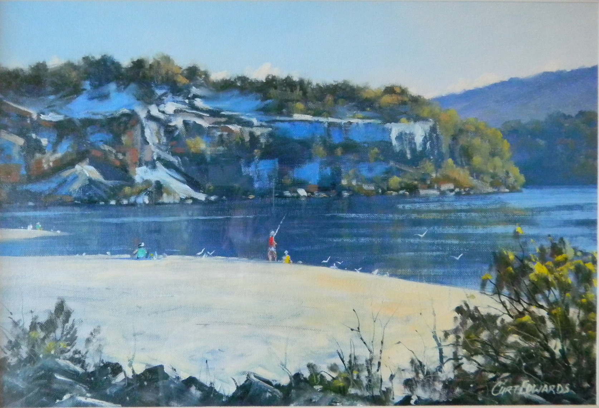
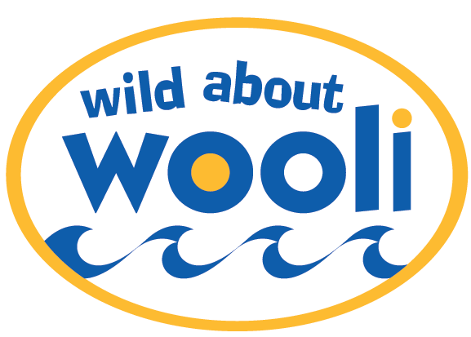
YOU ARE INVITED !
Wild About Wooli Art Show
Opening Night – Friday 29th March, 2013
at 6.30 pm - $10 Adults $5 children
Includes nibbles and a drink
And continues Saturday 30th & Sunday 31st March, 2013
at Wooli Hotel Motel – Games Room
ArtShow opened by Luke Hartsuyker MP
Supporting Coastal Communities Protection Alliance-Wooli Inc

