Invitation
wild about wooli ArtShow
PAINTING WORKS ON PAPER SCULPTURE FABRIC ART
18th - 20th April 2014 Wooli Hotel Motel
Opening Night Cocktail Party 6:30pm Friday 18th April – tickets $10 donation at door
Enquiries: www.protectwooli.com.au or leonecoper@gmail.com or phone Kathleen 0407 454 322
Invitation
wild about wooli ArtShow
PAINTING WORKS ON PAPER SCULPTURE FABRIC ART
18th - 20th April 2014 Wooli Hotel Motel
Opening Night Cocktail Party 6:30pm Friday 18th April – tickets $10 donation at door
Enquiries: www.protectwooli.com.au or leonecoper@gmail.com or phone Kathleen 0407 454 322

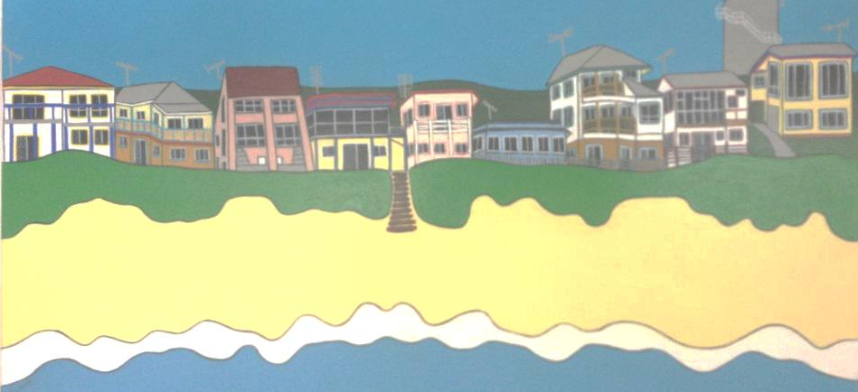

Invitation
wild about wooli ArtShow
PAINTING WORKS ON PAPER SCULPTURE FABRIC ART
18th - 20th April 2014 Wooli Hotel Motel
Opening Night Cocktail Party 6:30pm Friday 18th April – tickets $10 donation at door
Enquiries: www.protectwooli.com.au or leonecoper@gmail.com or phone Kathleen 0407 454 322

