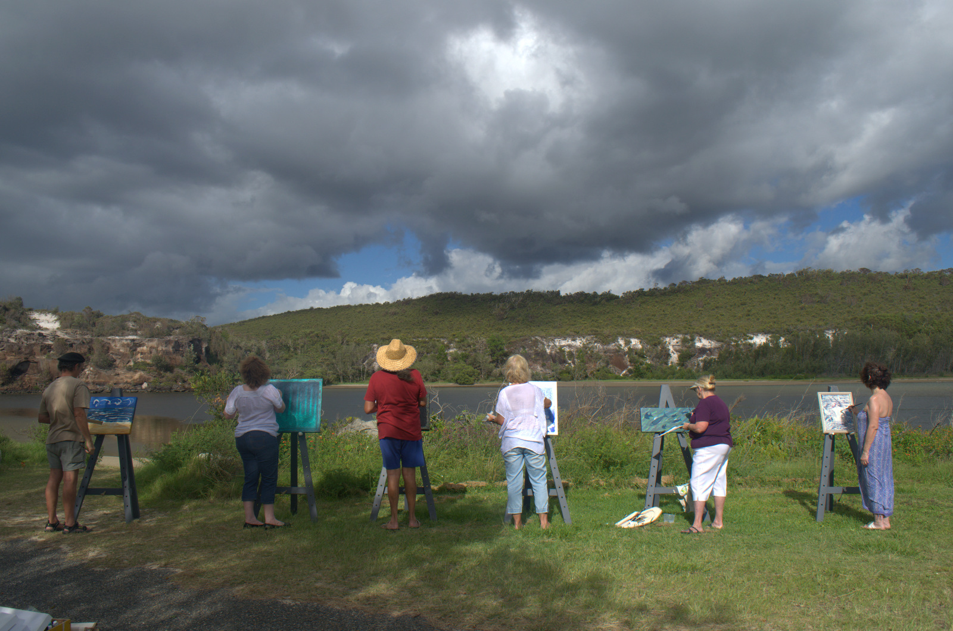
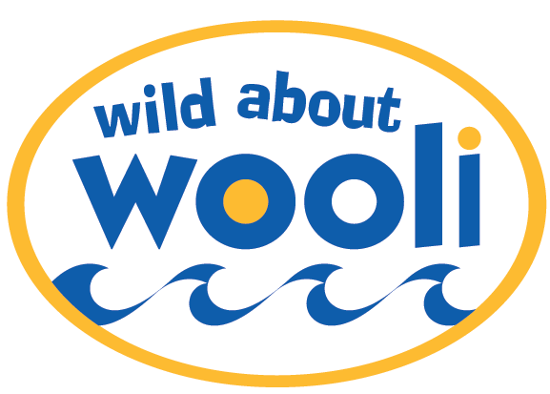
Wild About Wooli Art Show Easter 2014
Artists inspired by our beautiful Coast
You Are INVITED! to enter your
Painting Works on Paper Sculpture Fabric Art
Theme: Coast - Inspired
Application forms - leonecoper@gmail.com or phone 0468 300 860
Entry donation only $20 for up to 5 of your works
6:30pm Friday 18th April 2014 to 4pm Sunday 20th at Wooli Hotel Motel
Judged and People Choice prizes awarded
Supporting Coastal Communities Protection Alliance-Wooli Inc

