Wild About Wooli
2016 WOOLI ART SHOW
FUNDRAISER FOR COASTAL COMMUNITIES PROTECTION ALLIANCE WOOLI

Official Opening
6:30pm Friday 25 Mar 2016
Wooli Hotel Motel

JUDGE Jude McBean Grafton Regional Gallery Director
KEYNOTE ADDRESS Councillor Sue Hughes
Join us for the announcement of this year’s winners and celebrate regional artists.

$10 Entry Adult
$5 Children
Tickets available at the door Complimentary drink on arrival Delicious appetizers

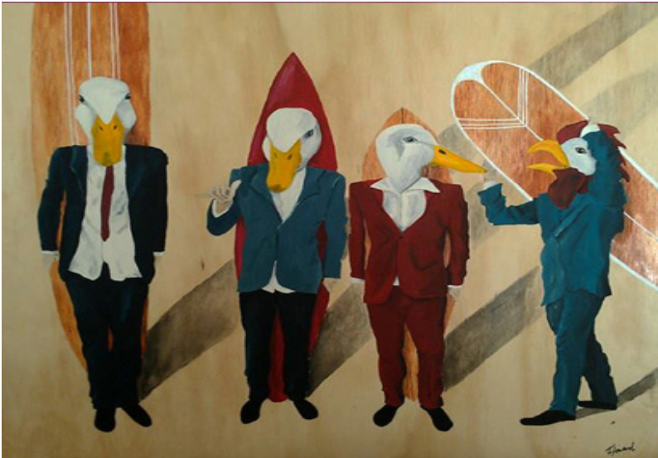painting | works on paper | textile art | sculpture | photography

2016 WOOLI ART SHOW
FUNDRAISER FOR COASTAL COMMUNITIES PROTECTION ALLIANCE WOOLI

COASTAL COMMUNITIES PROTECTION ALLIANCE - WOOLI
In October 2010 concerned citizens and friends of Wooli formed an association called the Coastal Communities Protect Alliance - Wooli (CCPA) to develop and implement plans for protecting Wooli beach from coastal erosion.

WOOLI ART GATHERING
In April 2011 Wooli Art Gathering (WAGS) held its inaugural exhibition. This included a children’s section from the local school and over one hundred works across several media.

Now in its sixth year the art show has five main categories: works on paper, textile art, sculpture, painting and photography and a successful children’s section.
The objective of the event continues to be a fundraiser for the CCPA along with celebrating local creativity.

Wooli Art Show is a proud CVC plunge festival event

www.clarence.nsw.gov.au/recreation/artsandculture/plunge

For further information go to

www.protectwooli.com.au

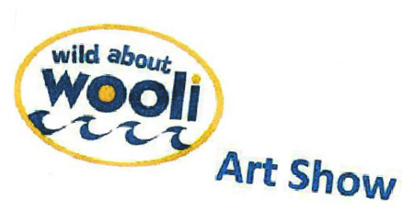Front: Tanya Howard Always One 2014 Winner 2014

https://www.facebook.com/pages/Wild-About-Wooli-Art-Show/161534420670936

